NAME | HASEEB RIAZ
REGISTRATION NUMBER | 5124693
DPAEPARTMENT | ELECTRICAL ENG (AI)
SECTION | “B”
SEMISTER | 2nd
SUBJECT | COMPUTER PROGRAMING

Objective
The primary goal of this lab is to master selection and flow control in C++ using the switch statement and its associated keywords. Students will learn to:
- Implement switch as an alternative to multiple if-else blocks.
- Utilize break to manage program flow and prevent "fall-through".
- Apply the continue statement within loops.
- Develop interactive, menu-driven programs.

Technical Overview
The Switch Statement
The switch statement is a multiple-selection statement that executes a specific block of code based on the value of a constant integral expression (integers or characters).
Key Components:
- Case:
Defines the starting point for execution if the expression matches the case value.
- Break:
Terminstes the statement sequence and jumps the control flow to the line following the switch block.
- Default:
An optional section that executes if no case matches the provided expression.
Important Rules
- The switch expression must result in a constant value.
- Duplicate case values are strictly prohibited.
- If break is omitted, execution will continue into the next case automatically.

EXAMPLE # 1
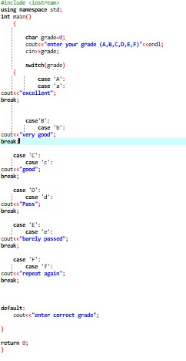

EXAMPLE # 2

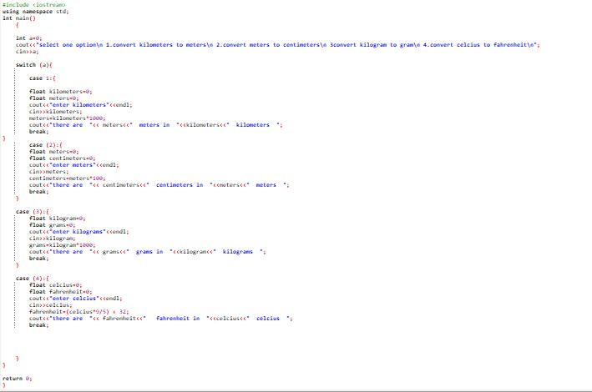

EXAMPLE # 3
